

IT Prerequisites
Purchase
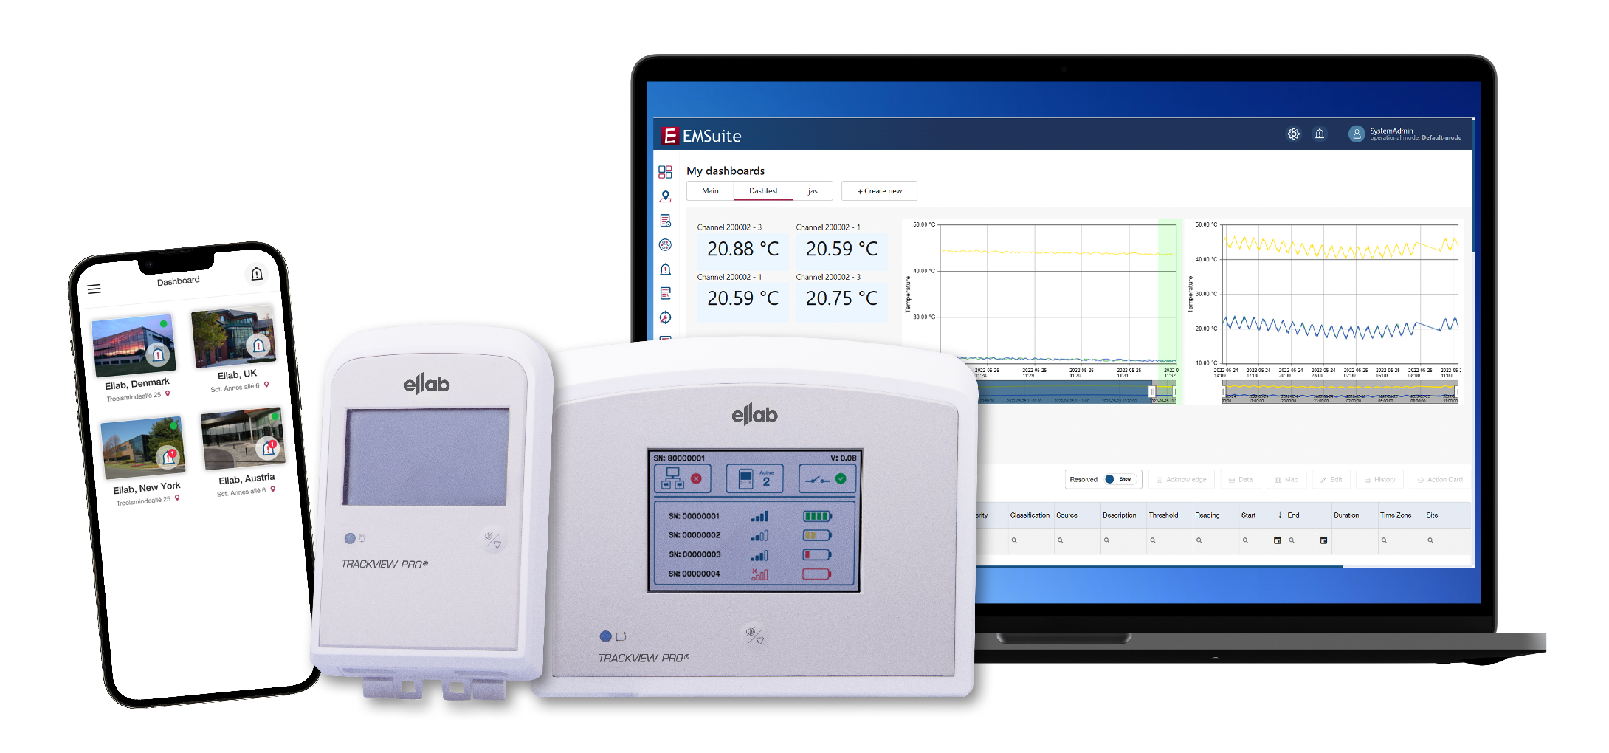

Contents
1. Overview 4
2. Access to EMSuite 5
3. Requirements 5
4. EMSuite installation structure 6
5. Browser Compatibility 6
6. Server Specifications 6
6.1 Database Server Specification 7
6.2 Application Web Server Specifications 7
6.3 Combined server 7
7. Ports 8
8. EMSuite mobile App 8
9. Authentication Method 8
10. URL 9
11. Configuration 9
11.1 Access point 9
11.2 PoE (Power over Ethernet) 9
12. Email service 10
12.1 Sendgrid 10
12.2 SMTP or SMTPS – (Secure)Simple Mail Transfer Protocol 10

Overview
Please ensure that you have read the EMSuite Manual, which answers most common questions regarding the hardware and software installation and operation of EMSuite.
Purchase
This solution requires a database either provided by the customer or Ellab.

Company Name:
Address:
Main Contact Details:
IT Contact Details:
EMSuite version:
Pro or Standard
Measuring Points:
Number of channels
Email for license:
Recipient for license activation key
Completed by:  Customer |  | Date:
Signature and date  By Ellab employee |  | Date:

Access to EMSuite
A validated version of EMSuite includes validation documents.
Validated version of EMSuite requires an Installation Qualification (IQ) document, which Ellab A/S completes and sends to responsible end-user
Access to EMSuite and its size are determined by a dedicated license, which is based on the number of measuring points (channels) purchased.

A dedicated license is sent via email from Ellab A/S to responsible end-user.

Requirements
The key requirements for an EMSuite installation:
- During installation the logged in Windows user must have Local Administrator permission
- The database Instance name must be known if the database server is an existing SQL server. An Instance user with permission matching the SA must be present
- Ports need to be configured in the network firewall
- The installation is handled by the customer however remote support is available if needed

EMSuite installation structure

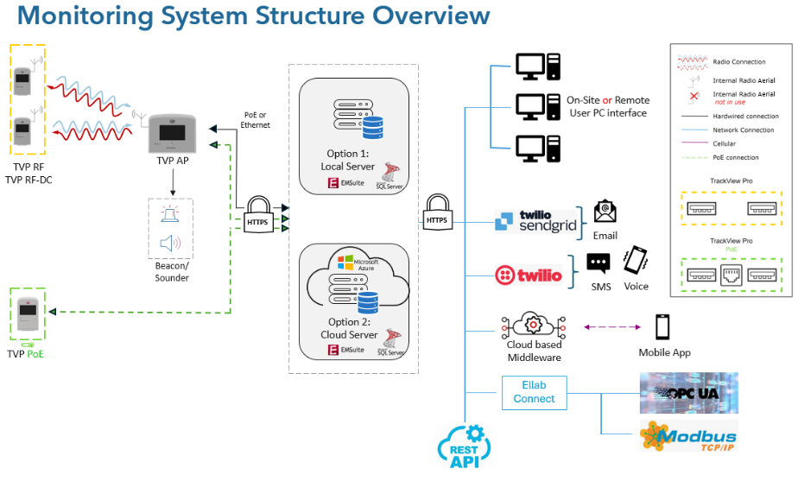

Browser Compatibility
The EMSuite System is scalable, browser based, with an SQL database and used through a browser and therefore must have internet access.
The Host machine and Client machines require one of the browsers below installed:
- Microsoft Edge. Version 111 or later.
- Google Chrome Version 112 or later.
- Mozilla Firefox Version 110 or later.

Server Specifications
Ellab recommends two options:
- Separate servers for EMSuite and Database
- Combined server for EMSuite and Database

It is possible to run Database and Application web server on one server but in that case a more powerful server is necessary.
The EMSuite SQL Server can either be an existing SQL server or a new SQL Server installed via EMSuite installation program.

Database Server Specification
Operating System:
- Microsoft Windows Server 2019 or newer/Windows 10/Windows 11

RAM:
- 8 GB
Hard Disk Space:
- Minimum 500 GB or more

Database:
- SQL Server 2017 or newer (Default installation will be Microsoft SQL 2019 Express (x64))

Application Web Server Specifications
Operating System:
- Minimum Microsoft Windows Server 2019

RAM:
- 8 GB
Hard Disk Space:
- Minimum 20 GB or more

Combined server
Operating System:
- Microsoft Windows Server 2019 or newer/Windows 10/Windows 11
Database:
- SQL Server 2017 or newer (Default installation will be Microsoft SQL 2019 Express (x64))
Hard Disk Space:
- 16 GB ram
- 500 GB Hard disk

Ports
Purchase/On premise systems require the correct ports to be open and network firewall rules to be configured on the server.
Port 44303 is the default but can after installation be altered to 443.

- From Access Point to Webserver: 44394
- Client browsers to Webserver: 44303

EMSuite mobile App
EMSuite includes mobile app access.
The mobile app requires a yearly update to be fully functional.

Minimum Operating System Requirements:
- Android 8
- iOS 13

Authentication Method

System administrator can choose the Authentication platform:

- Windows AD via LDAP(S) Port 389 or 636:
The IT department can use Windows AD to streamline user and rights management for Purchase/On-Premise EMSuite systems achieving centralized control of user configurations through the AD Group feature.

- SSO - Entra (Azure Active Directory) (AAD) Authentication via SAML or OIDC:
The IT department can use AD Entra authentication to streamline user and rights management while achieving centralized control over devices and user configurations through the Entra Group feature.
Entra AD is the evolution of the traditional Windows AD user handling system.

- SSO - OKTA Authentication via SAML or OIDC:
OKTA is a cloud-based service that allows users to log in to multiple applications and services with a single set of credentials. This can be integrated through SAML (Security Assertion Markup Language) or OIDC (OpenID Connect) to ensure secure communication.

- EMSuite Authentication:
EMSuite includes complete user management capabilities with username, email, passwords, viewing privileges. The customer can utilize this method or an alternative.

Authentication method:

URL

The default URL format will be the server’s name where the installation is located on, and then followed by port number 44303, example “customerserver:44303”. To change the URL name the responsible IT department will have to add the desired website name to the domain name system for the server.

Configuration

Access point
Access Point initiates contact with the EMSuite software via port 44394. Configuration requires information from the client.

If DHCP is selected network information is not required.

DHCP:
Fixed IP:

Network Information:
IPv4 or IPv6:
IP Address:
Subnet Mask:
Gateway:
Primary DNS:
Secondary DNS:

PoE (Power over Ethernet)

PoE Transmitter initiates contact with EMSuite software via Port 44394. Configuration requires information from the client.

If DHCP is selected, network information is not required.
DHCP:
Fixed IP:

Network Information:
IPv4 or IPv6:
IP Address:
Subnet Mask:
Gateway:
Primary DNS:
Secondary DNS:

Email service

Sendgrid
EMSuite utilizes SendGrid. Sendgrid is a cloud-based communication platform for sending and receiving emails. Sendgrid supports email authentication protocols such as SPF – sender policy framework and DKIM – DomainKeys identified mail. These protocols help ensure that sent emails are authenticated by recipient’s email servers, reducing the risk of emails being considered as spam.

To integrate Sendgrid we will require:
- Https port 443 to the internet

SMTP or SMTPS – (Secure)Simple Mail Transfer Protocol
EMSuite utilizes SMTP or SMTPS. SMTP - Simple Mail Transfer Protocol is a standard protocol for sending emails and is used by mail servers to transfer outgoing email messages from the sender mail server to the recipient mail server. SMTP operates over the internet IP protocol.
SMTPS – Secure Simple Mail Transfer Protocol is the secure version of SMTP and uses Secure Socket Layer or Transport Layer Security to encrypt the connection between the email client and the email server, ensuring that the data transmitted is secure and protected.

To integrate SMTP – Standard Mail Transfer Protocol we will require:
- HTTP port 25 to the internet

To integrate SMTPS – Secure Standard Mail Protocol we will require:
- HTTPS port 465 to the internet



EMSuite IT Prerequisites
Purchase

