


IT Prerequisites
Cloud

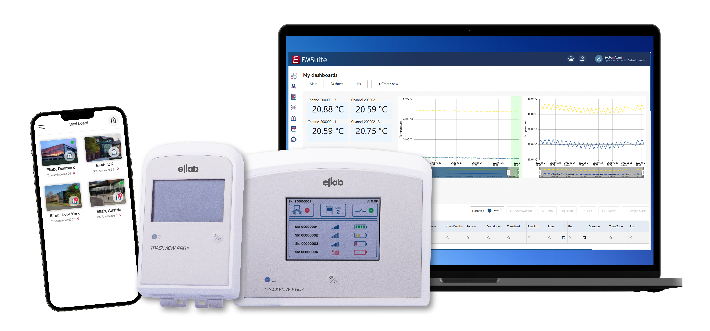

Contents
1. Overview 4
2. Access to EMSuite 5
3. Requirements 5
4. EMSuite installation Structure 5
4.1 Cloud-based solutions can be installed either: 6
5. Browser Compatibility 6
6. Ports 6
7. EMSuite mobile App 6
8. Authentication Method 7
9. URL 7
10. Configuration 8
10.1 Access point 8
10.2 PoE (Power over Ethernet) 8
11. Email service 9
11.1 Sendgrid 9
11.2 SMTP or SMTPS – (Secure)Simple Mail Transfer Protocol 9

Overview
Please ensure that you have read the EMSuite Manuals, which answers most common questions regarding the hardware and software installation and operation of EMSuite.

Cloud
This solution generates complete installation based on a template created in Microsoft Azure

Company Name
Address
Main Contact Details
IT Contact Details
EMSuite version:
Pro or Standard
Measuring Points:
Number of channels
Email for URL:
Recipient for dedicated URL
Email for IQ:
Recipient for IQ protocol (only for Pro version)
Completed by:  Customer |  | Date:
Reviewed by:  Ellab employee |  | Date:

Access to EMSuite

The validated version of EMSuite includes validation documents.
Validated version of EMSuite requires an Installation Qualification (IQ) document, which Ellab A/S completes and sends to responsible end-user.

Access to EMSuite and its size are determined by a dedicated license, which is based on the number of measuring points (channels) purchased.

A dedicated URL for the website access is sent via email from Ellab A/S to responsible end-user or Ellab sales representative.

Requirements

The key requirements for an EMSuite installation:
- Port 443 needs to be configured in the network firewalls.

EMSuite installation Structure

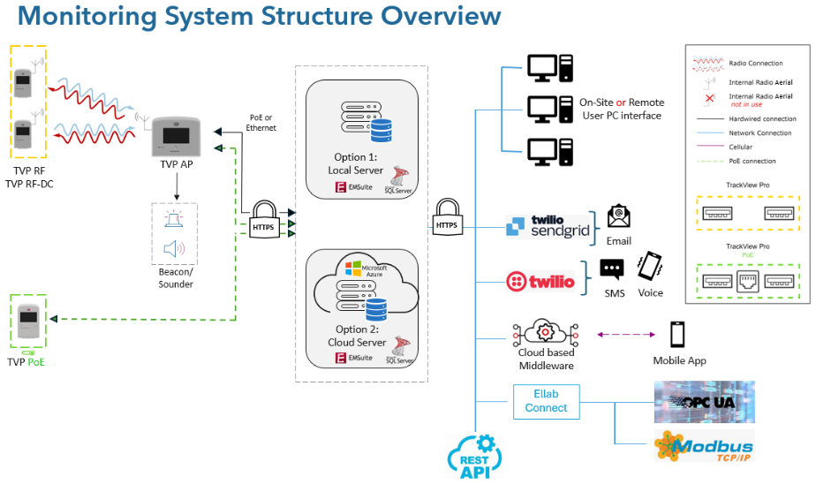

Cloud-based solutions can be installed either:

    - With customer provided Microsoft Azure tenant
    - With Ellab A/S Microsoft Azure tenant

Tenant provided by (customer/Ellab A/S):
Tenant location (country/region):

To deploy the server in the customer-provided tenant, Ellab A/S requires specific information from the customer:
Subscription ID:
Tenant ID:
App ID:
App Secret:

Browser Compatibility
The EMSuite System is scalable, browser based, with an SQL database and used through a browser and therefore must have internet access.

The Client machines require one of the browsers below Installed:
- Microsoft Edge 111 or later
- Google Chrome Version 112 or later
- Mozilla Firefox Version 110 or later

Ports
- From Access Point to Webserver: 443
- Client browsers to Webserver: 443

EMSuite mobile App

EMSuite includes mobile app access.

The mobile app requires a yearly update to be fully functional.
Minimum Operating System Requirements:
    - Android 8
    - iOS 13

Authentication Method

System administrator can choose the Authentication platform:
- SSO - Entra (Azure Active Directory) (AAD) Authentication via SAML or OIDC:
The IT department can use AD Entra authentication to streamline user and rights management while achieving centralized control of user configurations through the Entra Group feature.
Entra AD is the evolution of the traditional Windows AD user handling system.

- SSO - OKTA Authentication via SAML or OIDC:
OKTA is a cloud-based service that allows users to log in to multiple applications and services with a single set of credentials. This can be integrated through SAML (Security Assertion Markup Language) or OIDC (OpenID Connect) to ensure secure communication.

- EMSuite Authentication:
EMSuite includes complete user management capabilities with username, email, passwords, viewing privileges. The customer can utilize this method or an alternative.
Authentication method:
Configured through SAML or OIDC

URL
The URL will be accessible on mobile devices when using a cloud solution.
URL format:
The default URL format will be app-emsuite-xxxxx.azurewebsites.net, where the XXXXX is an abbreviation of the customer or company name.

Configuration

Access point
Access Point initiates contact with the EMSuite software via port 443. Configuration requires information from the client.
If DHCP is selected, network information is not required.

DHCP:
Fixed IP:

Network Information:
IPv4 or IPv6:
IP Address:
Subnet Mask:
Gateway:
Primary DNS:
Secondary DNS:

PoE (Power over Ethernet)

PoE Transmitter initiates contact with EMSuite software via Port 443. Configuration requires information from the client.

If DHCP is selected, network information is not required.

DHCP:
Fixed IP:

Network Information:
IPv4 or IPv6:
IP Address:
Subnet Mask:
Gateway:
Primary DNS:
Secondary DNS:

Email service

Sendgrid
EMSuite utilizes SendGrid. Sendgrid is a cloud-based communication platform for sending and receiving emails. Sendgrid supports email authentication protocols such as SPF – sender policy framework and DKIM – DomainKeys identified mail. These protocols help ensure that sent emails are authenticated by recipient’s email servers, reducing the risk of emails being considered as spam.

To integrate Sendgrid, we will require:
- HTTPS port 443 to the internet

SMTP or SMTPS – (Secure)Simple Mail Transfer Protocol
EMSuite utilizes SMTP or SMTPS. SMTP - Simple Mail Transfer Protocol is a standard protocol for sending emails and is used by mail servers to transfer outgoing email messages from the sender mail server to the recipient mail server. SMTP operates over the internet IP protocol.
SMTPS – Secure Simple Mail Transfer Protocol is the secure version of SMTP and uses Secure Socket Layer or Transport Layer Security to encrypt the connection between the email client and the email server, ensuring that the data transmitted is secure and protected.

To integrate SMTP – Standard Mail Transfer Protocol we will require:
- HTTP port 25 to the internet

To integrate SMTPS – Secure Standard Mail Protocol we will require:
- HTTP port 465 to the internet


EMSuite IT Prerequisites
Cloud

