Cycle Types:
Basic Cycles | Description | Typical Application or Load Type
Gravity | The most basic sterilization cycle. Steam displaces air in the chamber by gravity (i.e. without mechanical assistance) through a drain port. | Glassware, unwrapped goods, waste, utensils, redbags.
Pre-Vacuum and/or Post-Vacuum | Air is mechanically removed from the chamber and load through a series of vacuum and pressure pulses. This allows the steam to penetrate porous areas of the load that couldn’t otherwise be reached with simple gravity displacement. | Wrapped goods, packs, animal cage bedding, cages, porous materials, redbags.
Liquids | A gravity cycle with a slower exhaust rate to minimize boil-over. | Media, LB broth, water, etc.
Flash (Healthcare sterilizers only) | High temperature cycle (over 270F) for a shorter period of time. | Unwrapped goods

Some loads, the small quantities or liquid or heat sensitive goods, cannot withstand the parameters of a standard sterilization cycle. Advanced cycles alter parameters to sterilize the medium without destroying it.
Advanced Cycles | Description | Typical Application or Load Type
Effluent Decontamination | All steam effluent is captured, filtered, and sterilized prior to discharging down the drain. | BSL-3 contaminated goods such as waste, liquids, etc.
Low Temperature | Sterilization near the boiling point of water (180-220F) | Insippation or pasteurization of heat-sensitive goods.
Air-Over-Pressure | Air maintains the pressure in chamber during exhaust phase until temperature of load drops below an adjustable value. | Small quanitites of liquids (<10ml/vial) in danger of boiling over.
F₀ Cycle | Sterilization begins when temperature reaches a minimum of 212F and is completed when the F0 set-point is achieved. F0 is adjustable. | Heat-sensitive media and liquids
Validation, Bowie-Dick Test | Daily air removal test, typically for healthcare applications | Validating the sterilizer.
Validation, Vacuum Leak Test | Tests for air-tight integrity of chamber. | Validating the sterilizer.
Pressure Ramping | Steam pressure in the chamber can be ramped-up or ramped-down at an adjustable rate. | Loads sensitive to rapid pressure change (e.g. heart valves)
Temperature Ramping | Temperature in the chamber is ramped-up at an adjustable rate until exposure set-point temperature is achieved. | Loads sensitive to rapid temperature change
Rapid Cool – Jacket | During the cooling phase, cold water enters the jacket to speed up the cooling process. | Customers looking to decrease cycle time
Rapid Cool – Spray | During the cooling phase, cold water is sprayed into the chamber, showering the load, thereby speeding up the cooling process. | Customers looking to decrease cycle time
Continuous | Any sterilization cycle can be programmed to be continuously repeated (number of times is adjustable) without any input from the operator. | Validation of product.
Steam-Air Mix | Sterilization at an elevated pressure relative to temperature. Extra pressure is achieved using air. | Liquid-filled syringes.
Tight Temp Control | Utilizes an additional, small chamber steam valve to tightly control temperature during sterilization. Also includes temperature ramp up. | Customers with strict temperature tolerance.

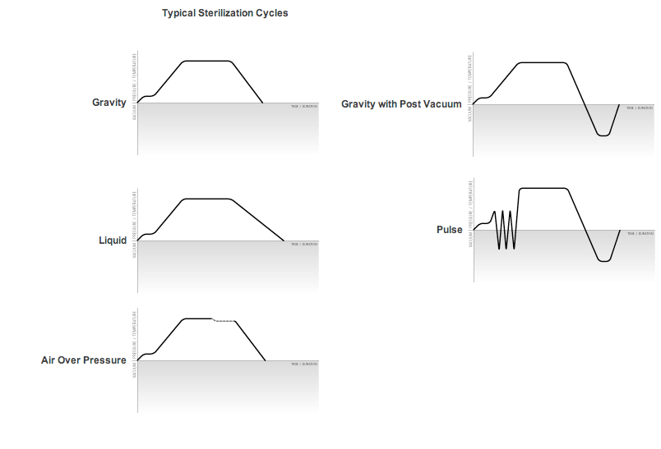

Guidelines for Optimum Cycle Types
Cycle Type | Application/Load | Temperature | Sterilization Time (Minutes) | Pre-Vac Pulses  psi – in/Hg | Dry Time  (minutes)
Gravity | Glassware, unwrapped goods, waste, utensils, redbags | 250°F (121°C) | 30-90 | None | 0-30
Pre-vacuum and/or post-vacuum | Wrapped goods, packs, animal bedding, cages, porous materials | 250°F (121°C) | 20-90 | 18 psi, 20in/Hg  0-6 pulses | 0-30
Liquids | Media, LB broth, water | 250°F (121°C) | 20-90 | – | 0.5 psi/minute
Flash | Unwrapped goods | 270°F (132°C) | 3-10 | – | 0-10

Sterilization Cycle Phases
- Purge
  - Steam enters the chamber and displaces ambient air by expelling it through the chamber drain. This displacement can occur by gravity or with use of a vacuum system.
  - All outlet valves are OPEN during this phase.
  - Discussion
    - Air in the chamber acts as a barrier to adequate steam penetration and will negatively affect the sterilization process. A heavily loaded sterilizer will contain many “pockets” where air may become trapped. “Conditioning” aids in the removal of this air, helping to prevent stratification of the functional steam/air mixture.
    - Conditioning times can be programmed by the operator and can last from 30 seconds to several minutes.
    - The overall length of the Conditioning phase will depend on the following factors:
      - Quantity and pressure of the supplied steam.
      - Density of the goods in the chamber.
      - Chamber size.
- Pre-Vacuum (Vacuum System Required)
  - Ambient air is efficiently removed from the chamber and the load. This allows steam to completely penetrate the products being sterilized.
  - This phase is useful for porous instruments or wrapped goods.
  - Alternative steam and vacuum phases creates pressure/vacuum “pulses”.
- Sterilization (Dwell)
  - Interior temperature and pressure are maintained at setpoint for a time specified by the controller or manual protocol.
- Drying (Cool Down)
  - The interior load returns to ambient temperature and pressure in any of three typical methods.
    - Gravity (Fast Exhaust)
      - This method allows the steam and condensate to exit through the chamber drain with no mechanical assistance. As the effluent discharges, the pressure and temperature in the chamber decrease. When the chamber pressure is near zero, the door can be opened and the goods may be removed. This method is simple, but not the fastest.
    - Gravity (Slow Exhaust)
      - For liquids. The cool down is gradual to permit dissolved gases in the liquid media to reach equilibrium; this avoids boilover until ambient temperature and pressure are restored.
      - Liquid, air-over-pressure. The cool down is gradual as pressurized air is injected to replace steam, thereby lowering the interior temperature under pressure and preventing smaller media samples from evaporating. Once temperature is reduced, air pressure is gradually equalized and ambient temperature and pressure are achieved.
    - Vacuum Drying (Post Vacuum)
      - A vacuum system pulls the steam and condensate through the drain port. The longer the vacuum system runs during the dry phase, the cooler and dryer the goods will be when removed from the chamber.
      - The Vacuum exhaust is programmed to run for a settable amount of time.
      - Vacuum exhaust should not be used on sterilized liquid because a quick reduction in pressure will cause the liquid to boil over.

Sterilization Cycle Parameters
Many first-time sterilizer users want to know how to select the best cycle parameters for their applications. The answer depends on at least four factors:
- Size of load
- Type of load (waste, media, glassware, or other)
- Time and throughput constraints
- Steam source (house steam, integral steam generation or other)

